Design Research and Planning

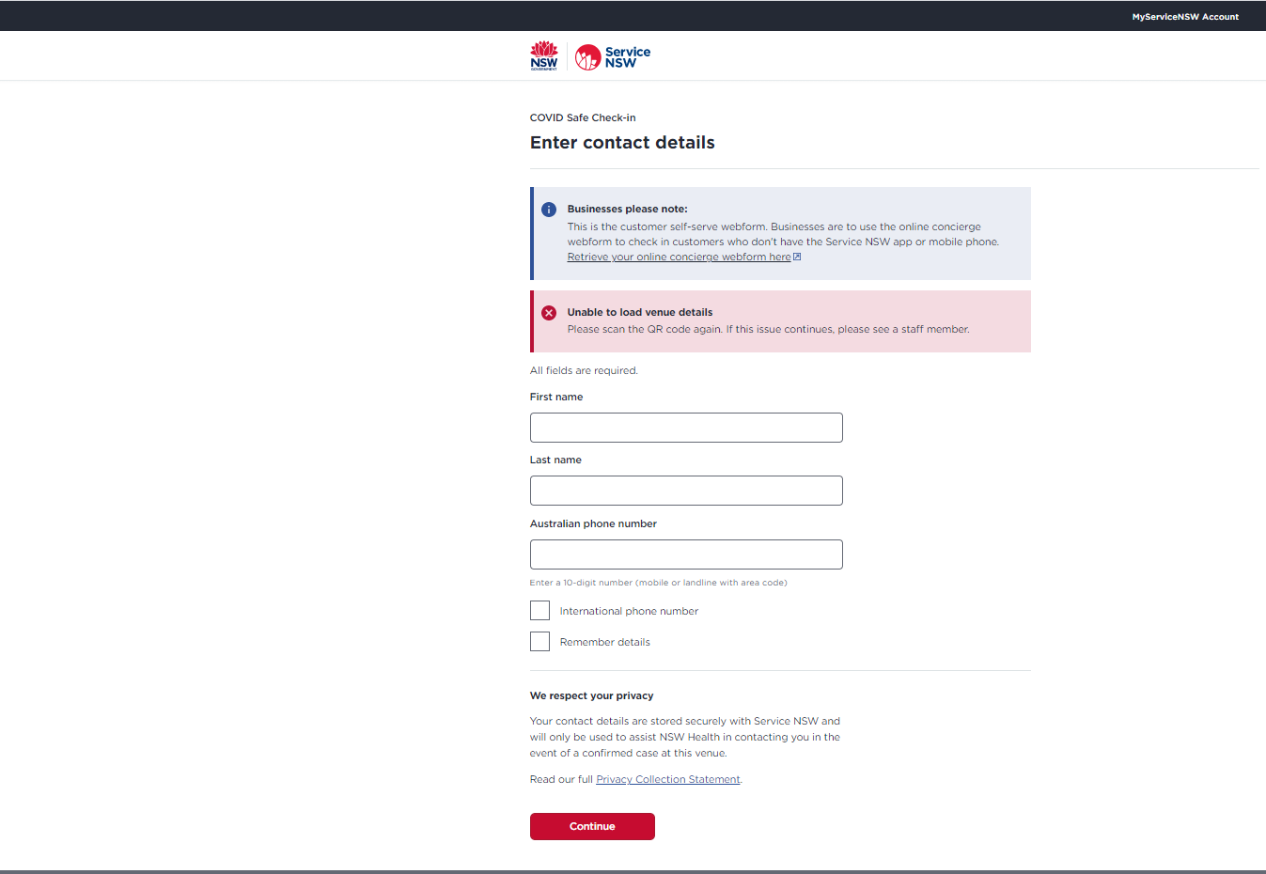

We started out by looking for contact tracing websites. Service NSW is the first website that we found. On the home page, it takes the user straight to the check-in page with all the necessary details. The layout out and design is simple and straightforward; it makes use of framing. The style is quite basic as well; the website employs a clean black header and a white background, which makes the website extremely readable. The only critique is that there is a lot of blank space on the page; this blank space could easily be filled with extra information/details about the site.

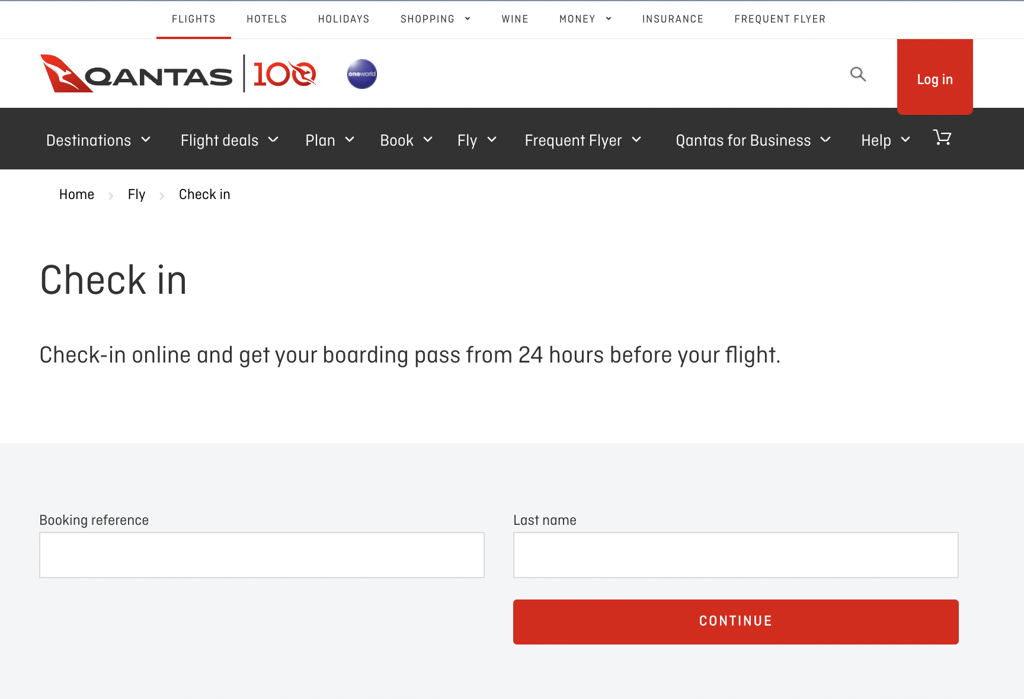

We then found the Qantas page for checking into flights, which we thought had a very intuitive and very well designed interface. The main focus of the page is accentuated by the large form, taking up almost the entire page. The use of empty space also allows for the user to immediately identify important elements, such as name and check-in location, so important information is kept in close proximity. We could emulate the simplicity of the check-in system by adapting the large form to allow users to check-in to a location. Another excellent stylistic feature of this website is the black header menu. Users can easily see the different components of the site within this navbar, and we can provide a drop-down menu within these options to provide additional links. On the other hand, we would not implement two separate menu bars at the top of the page, as the Qantas website has done. This would make navigation more challenging for the user; a single menu interface will help us limit cognitive load as much as possible in the layout of our site, as the user can easily find where the main is within the site.

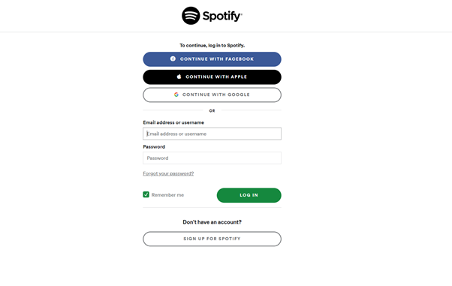

One of the required features of the COVID-19 Contact Tracing Web Application is that users should be able to sign up with a Google Account and log in to the system. The log-in and sign-up pages should be easy to use, showing all of the information that the user needs. The Spotify log-in page provides a great example of an effective log-in page. It takes a minimalist approach, as the content is clearly centred with a white background. The logo is clearly visible at the top of the screen, showing the user what log in page they are in. The option to log-in with a Google Account is another feature we aim to include. The buttons have rounded borders design with the colour scheme matching Spotify’s logo and modern aesthetic. We may adapt Spotify’s colour scheme to suit the colour scheme our site employs.

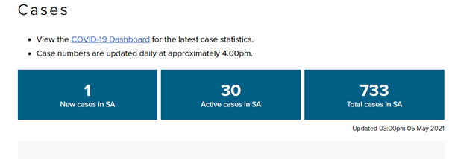

The SA Health website<https://www.sahealth.sa.gov.au/> shows a great example of information we could display to an Admin/Health Official regarding the changing number of cases. Furthermore, the style of boxes with a blue background colour help to highlight the most significant data regarding cases in SA. The use of large text to show numbers is also effective to emphasise important details to the user. We may decide to show more information, such as hotspots or cases in quarantine.

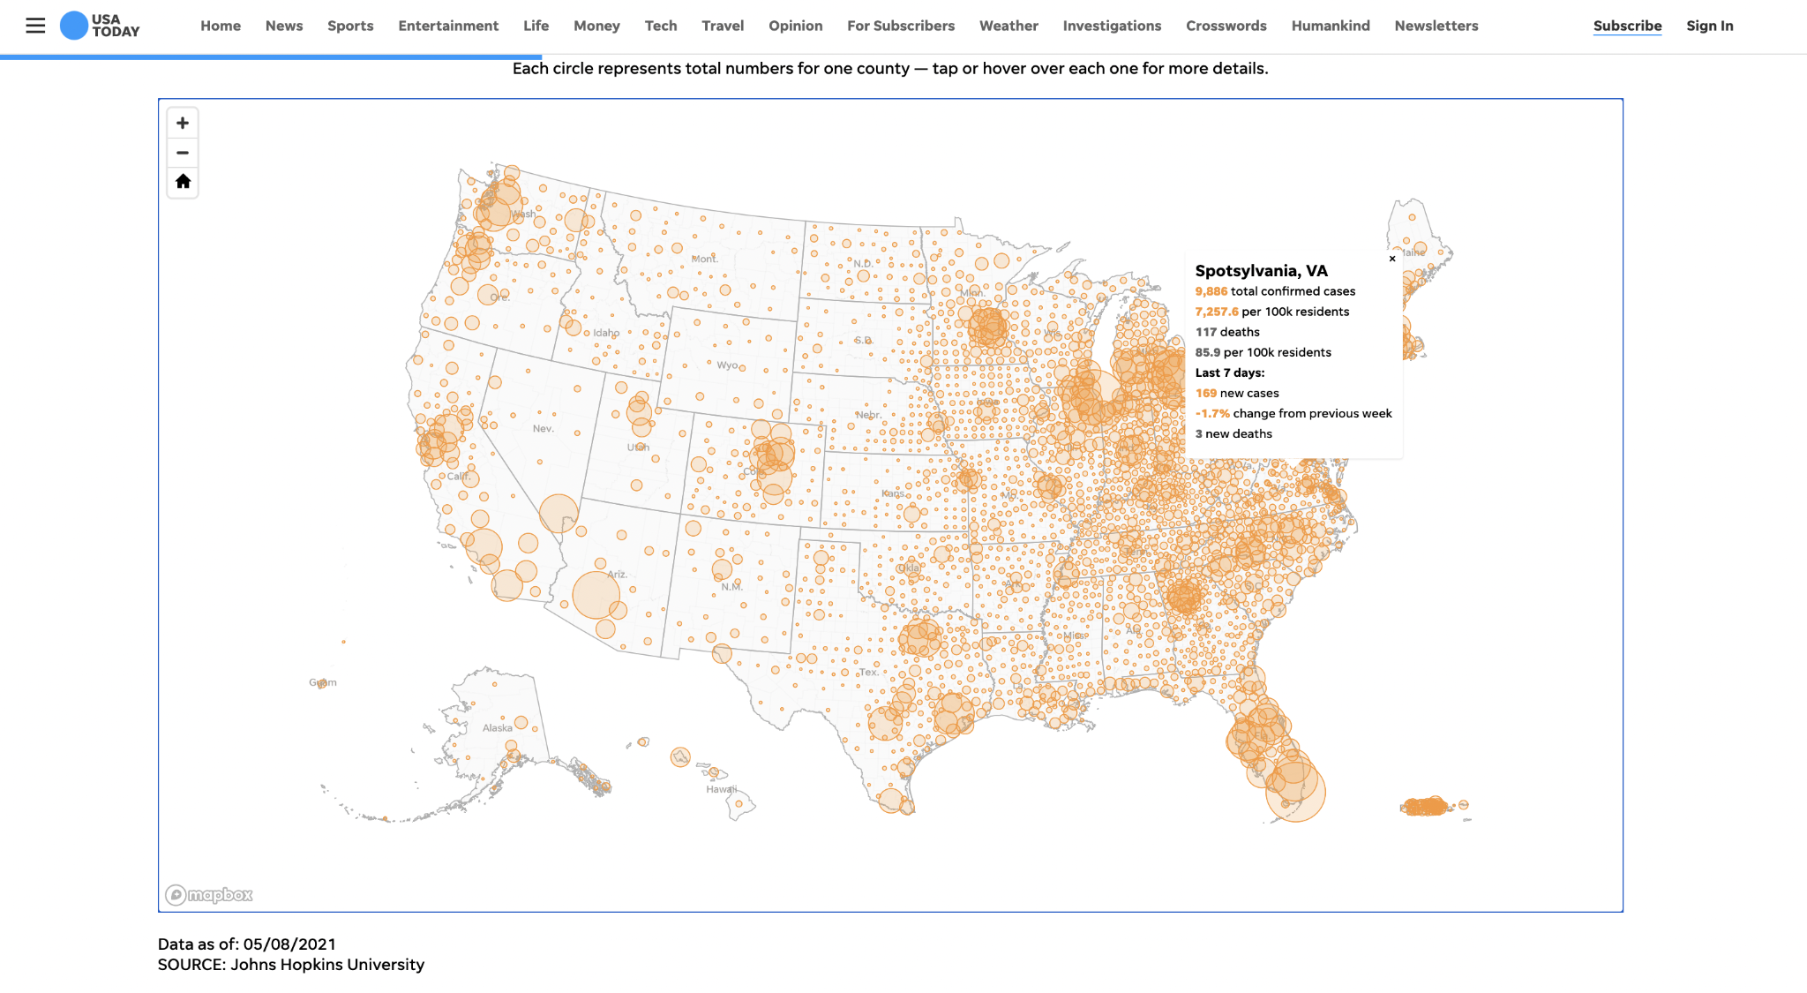

The SA Health website shows an example of an implementation of the interactive hotspot map feature, where the severity of a hotspot area is represented by the size of the circle drawn in that location. The user is able to zoom in and out using the navigation bar on the left and view details of a specific location by clicking on it. This design allows for the user to immediately recognise locations of greater severity at a glance by looking at how closely the circles are clumped together. The contrast between the white background and the darker circles further helps with glance value. The only negative is that the hotspots are quite hard to see, and the information displayed as a popup is quite small. On the other hand, zooming in should mitigate this issue.

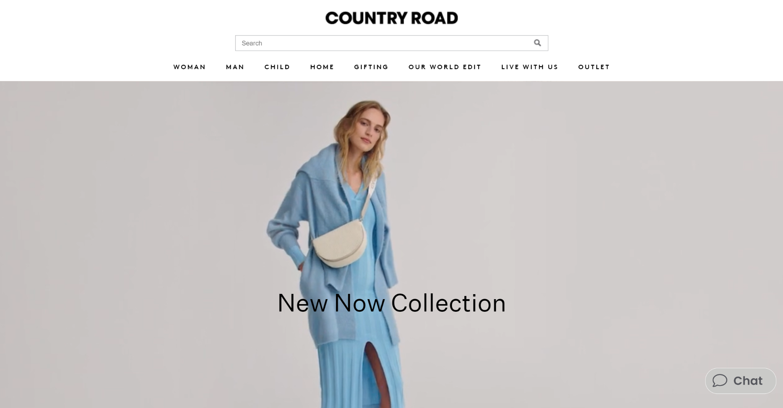

The Country Road website is a great example of the structure we would implement. It has a very minimalistic top menu; we like the possibility of a search bar at the top, that allows users to search for anything within the site. The menu is also extremely simple; it does not have any drop-down options but the text does have a visually appealing font style and layout in the centre of the page. The only negative aspect of this site is the colour scheme. We would prefer a coloured header bar to ensure the menu information is distinguished from the rest of the page.

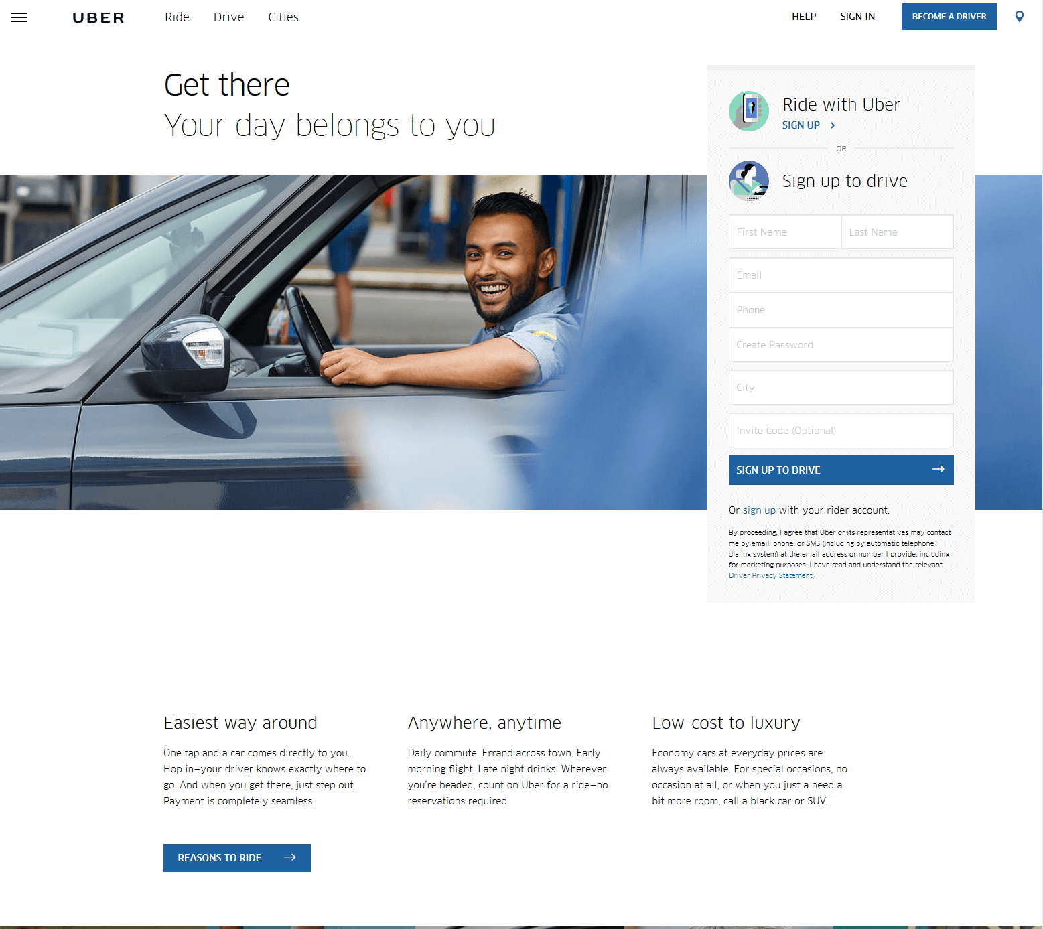

The Uber example is a great option of how we could structure our landing page. The login on the right-hand side is a white form with an image that covers the length of the page. The idea of a background image is quite interesting. We may not need to include a navigation bar at the top, so we could use the top-third of the page for a heading or website description. The only negative here is that we may not need to include a background image for the landing page; we could easily just have a form that takes up the centre of the page, allowing a user to log in.

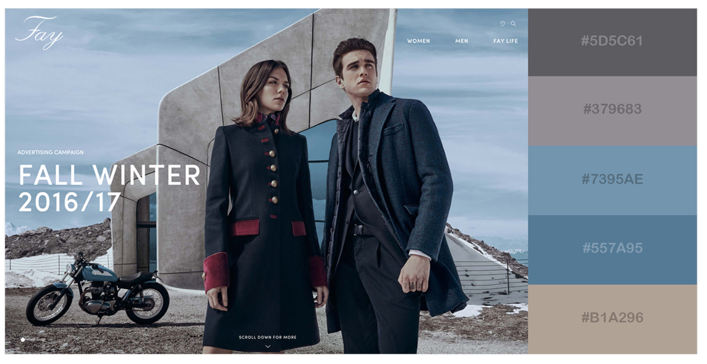

The above website provides an example of a potential colour scheme we could implement. The combination of muted colours creates a professional, sophisticated feel for the website. This is something we could use when we create our menu nav - a darker grey or blue would blend quite well with a lighter background for the page itself. The only drawback of this website is that the colour scheme may not fit our audience; the audience may expect a more basic, stripped back colour scheme that is not dissimilar to the NSW Health website described previously.